
Symbiosis Institute of Technology, Pune
Faculty of Engineering
CSE- Academic Year 2026-27
Java Programming – Lab Batch 2025-29
Lab Assignment No:- 24
Name of Student | Aarushi Raizada
PRN No. | 25070122002
Batch | 2025-29
Class | A1
Academic Year & Semester | 2026 SEM III
Date of Submission | 10/10/26
Title of Assignment: | Develop a Java GUI application integrated with JDBC to perform database operations.
Theory  Practice questions | Java Swing provides graphical user interface components such as buttons, labels, text fields, tables, and forms, while JDBC enables database connectivity. Combining Swing with JDBC allows developers to create interactive desktop applications capable of performing database operations through a graphical interface. Users can enter information using GUI components, which is then processed and stored in the database using SQL queries. Retrieved records can be displayed in tables or text fields for easy viewing and modification. This integration improves user experience by eliminating command-line interaction and forms the foundation of desktop applications such as inventory management systems, library management systems, and student management systems. Java applications.  1. Create a Library Management System GUI connected with database  import javax.swing.*;  import java.awt.*;  import java.sql.*;  public class LibraryManagement extends JFrame {  JTextField id, name, author, quantity;  JTextArea output;  Connection con;  LibraryManagement() {  setTitle("Library Management System");  setSize(500, 500);  setLayout(new FlowLayout());  try {  con = DriverManager.getConnection(  "jdbc:mysql://localhost:3306/library_db",  "root", "Aarushi@7002"  );  } catch (Exception e) {  JOptionPane.showMessageDialog(this, "Database connection failed!");  }  id = new JTextField(15);  name = new JTextField(15);  author = new JTextField(15);  quantity = new JTextField(15);  output = new JTextArea(12, 40);  output.setEditable(false);  add(new JLabel("Book ID:"));  add(id);  add(new JLabel("Book Name:"));  add(name);  add(new JLabel("Author:"));  add(author);  add(new JLabel("Quantity:"));  add(quantity);  JButton addBtn = new JButton("Add Book");  JButton viewBtn = new JButton("View Books");  JButton deleteBtn = new JButton("Delete Book");  add(addBtn);  add(viewBtn);  add(deleteBtn);  add(new JScrollPane(output));  addBtn.addActionListener(e -> addBook());  viewBtn.addActionListener(e -> viewBooks());  deleteBtn.addActionListener(e -> deleteBook());  setDefaultCloseOperation(JFrame.EXIT_ON_CLOSE);  setVisible(true);  }  void addBook() {  try {  String sql = "INSERT INTO books VALUES (?, ?, ?, ?)";  PreparedStatement ps = con.prepareStatement(sql);  ps.setInt(1, Integer.parseInt(id.getText()));  ps.setString(2, name.getText());  ps.setString(3, author.getText());  ps.setInt(4, Integer.parseInt(quantity.getText()));  ps.executeUpdate();  JOptionPane.showMessageDialog(this, "Book added successfully!");  } catch (Exception e) {  JOptionPane.showMessageDialog(this, e.getMessage());  }  }  void viewBooks() {  try {  output.setText("");  Statement st = con.createStatement();  ResultSet rs = st.executeQuery("SELECT * FROM books");  while (rs.next()) {  output.append(  "ID: " + rs.getInt("book_id") +  ", Name: " + rs.getString("book_name") +  ", Author: " + rs.getString("author") +  ", Quantity: " + rs.getInt("quantity") + "\n"  );  }  } catch (Exception e) {  JOptionPane.showMessageDialog(this, e.getMessage());  }  }  void deleteBook() {  try {  String sql = "DELETE FROM books WHERE book_id = ?";  PreparedStatement ps = con.prepareStatement(sql);  ps.setInt(1, Integer.parseInt(id.getText()));  int rows = ps.executeUpdate();  if (rows > 0)  JOptionPane.showMessageDialog(this, "Book deleted!");  else  JOptionPane.showMessageDialog(this, "Book not found!");  } catch (Exception e) {  JOptionPane.showMessageDialog(this, e.getMessage());  }  }  public static void main(String[] args) {  new LibraryManagement();  }  }  2. Create a Book Issue Tracking System GUI application using Java Swing connected to a database. The system should store book ID, student name, issue date, and return date, and allow record management.  import javax.swing.*;  import java.awt.*;  import java.sql.*;  public class BookIssueTracking extends JFrame {  JTextField id, student, issue, ret;  JTextArea output;  Connection con;  BookIssueTracking() {  setTitle("Book Issue Tracking System");  setSize(500, 500);  setLayout(new FlowLayout());  try {  con = DriverManager.getConnection(  "jdbc:mysql://localhost:3306/issue_db",  "root", "your_password"  );  } catch (Exception e) {  JOptionPane.showMessageDialog(this, "Database connection failed!");  }  id = new JTextField(15);  student = new JTextField(15);  issue = new JTextField(15);  ret = new JTextField(15);  output = new JTextArea(12, 40);  output.setEditable(false);  add(new JLabel("Book ID:"));  add(id);  add(new JLabel("Student Name:"));  add(student);  add(new JLabel("Issue Date (YYYY-MM-DD):"));  add(issue);  add(new JLabel("Return Date (YYYY-MM-DD):"));  add(ret);  JButton addBtn = new JButton("Issue Book");  JButton viewBtn = new JButton("View Records");  JButton deleteBtn = new JButton("Delete Record");  add(addBtn);  add(viewBtn);  add(deleteBtn);  add(new JScrollPane(output));  addBtn.addActionListener(e -> addRecord());  viewBtn.addActionListener(e -> viewRecords());  deleteBtn.addActionListener(e -> deleteRecord());  setDefaultCloseOperation(JFrame.EXIT_ON_CLOSE);  setVisible(true);  }  void addRecord() {  try {  String sql = "INSERT INTO book_issue VALUES (?, ?, ?, ?)";  PreparedStatement ps = con.prepareStatement(sql);  ps.setInt(1, Integer.parseInt(id.getText()));  ps.setString(2, student.getText());  ps.setDate(3, Date.valueOf(issue.getText()));  ps.setDate(4, Date.valueOf(ret.getText()));  ps.executeUpdate();  JOptionPane.showMessageDialog(this, "Book issue record added!");  } catch (Exception e) {  JOptionPane.showMessageDialog(this,  "Error: Check Book ID and dates (YYYY-MM-DD).");  }  }  void viewRecords() {  try {  output.setText("");  Statement st = con.createStatement();  ResultSet rs = st.executeQuery("SELECT * FROM book_issue");  while (rs.next()) {  output.append(  "Book ID: " + rs.getInt("book_id") +  ", Student: " + rs.getString("student_name") +  ", Issue Date: " + rs.getDate("issue_date") +  ", Return Date: " + rs.getDate("return_date") + "\n"  );  }  } catch (Exception e) {  JOptionPane.showMessageDialog(this, e.getMessage());  }  }  void deleteRecord() {  try {  String sql = "DELETE FROM book_issue WHERE book_id = ?";  PreparedStatement ps = con.prepareStatement(sql);  ps.setInt(1, Integer.parseInt(id.getText()));  int rows = ps.executeUpdate();  if (rows > 0)  JOptionPane.showMessageDialog(this, "Record deleted!");  else  JOptionPane.showMessageDialog(this, "Record not found!");  } catch (Exception e) {  JOptionPane.showMessageDialog(this, e.getMessage());  }  }  public static void main(String[] args) {  new BookIssueTracking();  }  }
Output Screenshots (if applicable) | Ans1  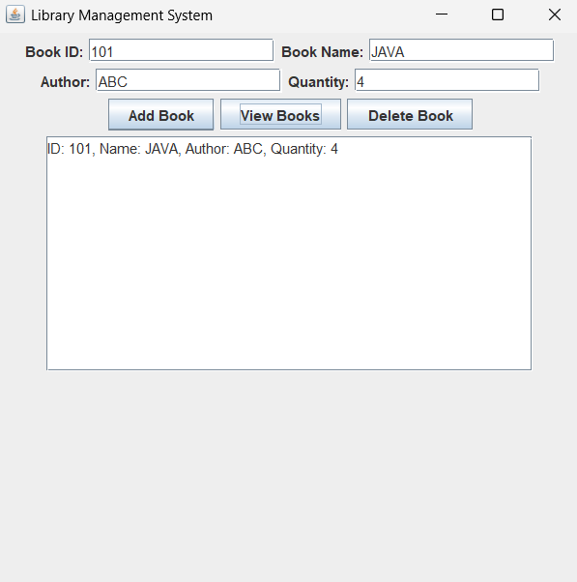  Ans 2  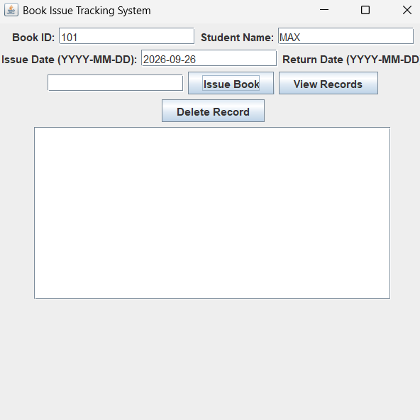
Conclusion | Both applications demonstrate how Java Swing and JDBC can be integrated with MySQL to build GUI-based database management systems. The Library Management System manages book records, while the Book Issue Tracking System maintains and manages book issue details..

